A000-ME-Mesopotamia-Sumeria-Cylinder Seal-Master of Animals-2000 BCE

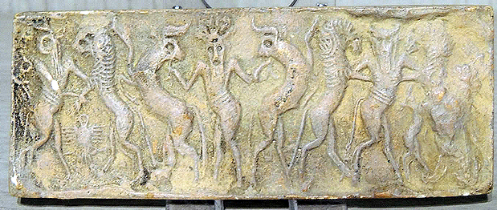

**Case no.:**

**Accession Number:**

**Formal Label:** Mesopotamia-Sumeria-Cylinder Seal-Master of Animals-2000 BCE

**Display Description:**

Master of Animals or Lord of Animals is an Ancient Near Eastern bilateral socio-cultural motif of a human grasping two confronted animals that may be realistic or fantastical, and the human figure may be theriomorphic displaying elements such as horns, or an animal upper body that may be related to his shamanic nature or his divine attributes. This bilateral iconography sometimes has ritualistic and religious associations.

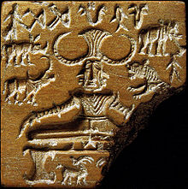 

The Pashupati steatite seal (ca 2000 BCE) and its impression. After <http://www.columbia.edu/itc/mealac/pritchett/00routesdata/bce_500back/indusvalley/protoshiva/protoshiva.jpg>

The Pashupati seal (ca 2000 BCE) discovered at Mohenjo-daro of the Indus Valley Civilization depicts a seated figure with a horned headdress surrounded by animals and may represent one of the earliest depictions of the Hindu god Shiva who is regarded as a lord of animals (Werness 2006: 270).

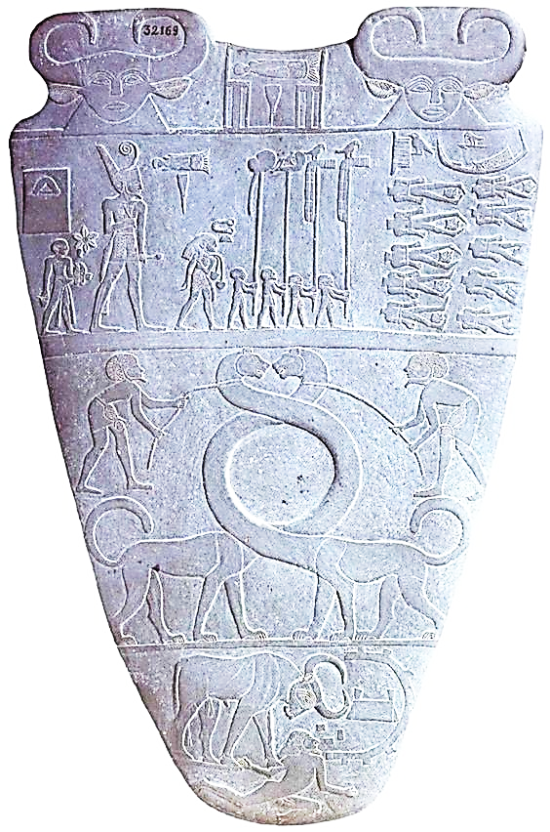

Verso of the Narmer palette ca 3000 BCE. After http://realhistoryww.com/world_history/ancient/Stele/narmer_palette.jpg

Without the male central figure, the opposing animal figures may represent the balance of power achieved under a specific ruler such as the so-called serpopards (serpent-leopards) on the verso of the Narmer palette, ca 3000 BCE.

Without the male central figure, another example is the opposing lionesses in the Lion Gate of Mycenae in north-eastern Peloponnese, Greece, which has a column between two confronted lionesses standing with two feet on the same base on which the column rests (Tessier 1984: 46).

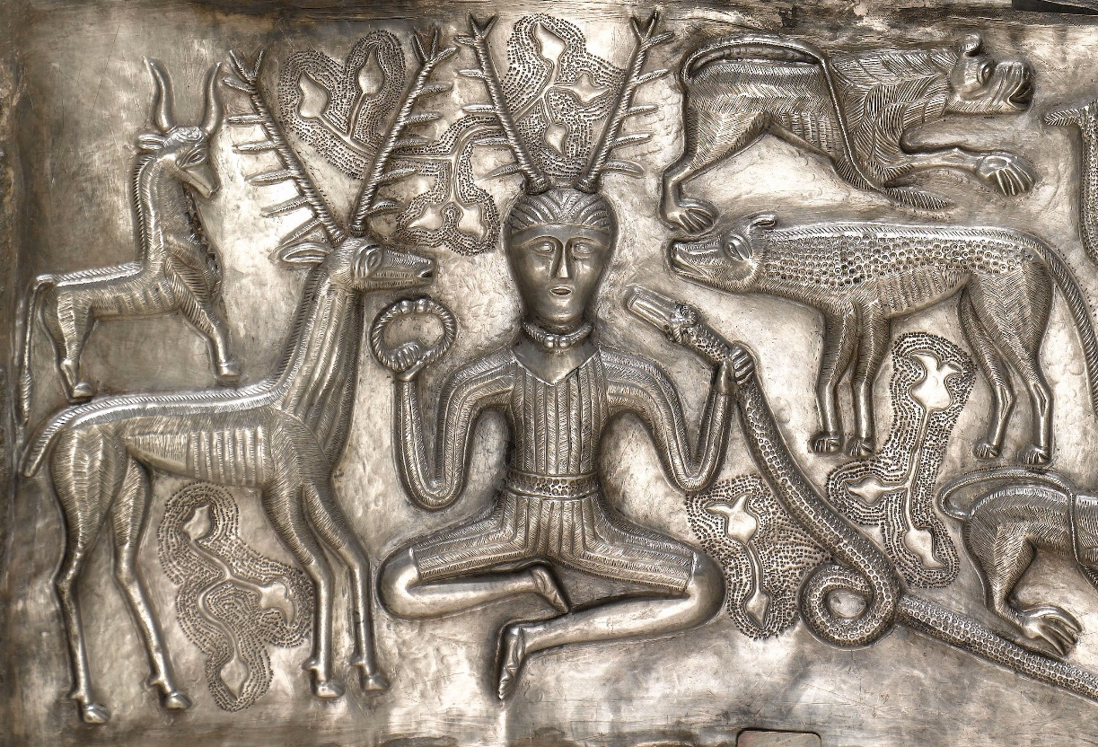

**LC Classification:**

**Date or Time Horizon:**

**Geographical Area:**

**Map:**

**GPS coordinates:**

**Cultural Affiliation:**

**Media:**

**Dimensions:**

**Weight:**

**Condition:**

**Provenance:**

**Discussion:**

**References:**

Teissier, Beatrice, *Ancient Near Eastern Cylinder Seals from the Marcopolic Collection*, p. 46, 1984, University of California Press,

Werness, Hope B., *Continuum Encyclopedia of Animal Symbolism in World Art*, p. 270, 2006, A&C Black